Django day- 8 Task by – RIYA SARKAR

COLLEGE – SSIT

Contains the screenshot of the task –

**REGISTRATION FORM**

1. **AN APP NAMED – MYREGISTRATIONFORM HAS BEEN CREATED**
2. **AND THEN THE SCREENSHOTS OF FURTHER PROCESS IS ATTACHES**

**3) ITS DJANGO TASK – HOMEWORK – SIGN IN**

**FORM**

**DAY 8.**

🡪 COMMAND PROMPT

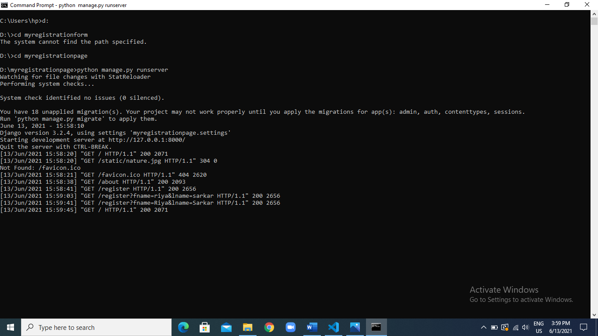

THE IMAGE OF VSCODE CODE AREA- CONATINS LIST OF FOLDERS

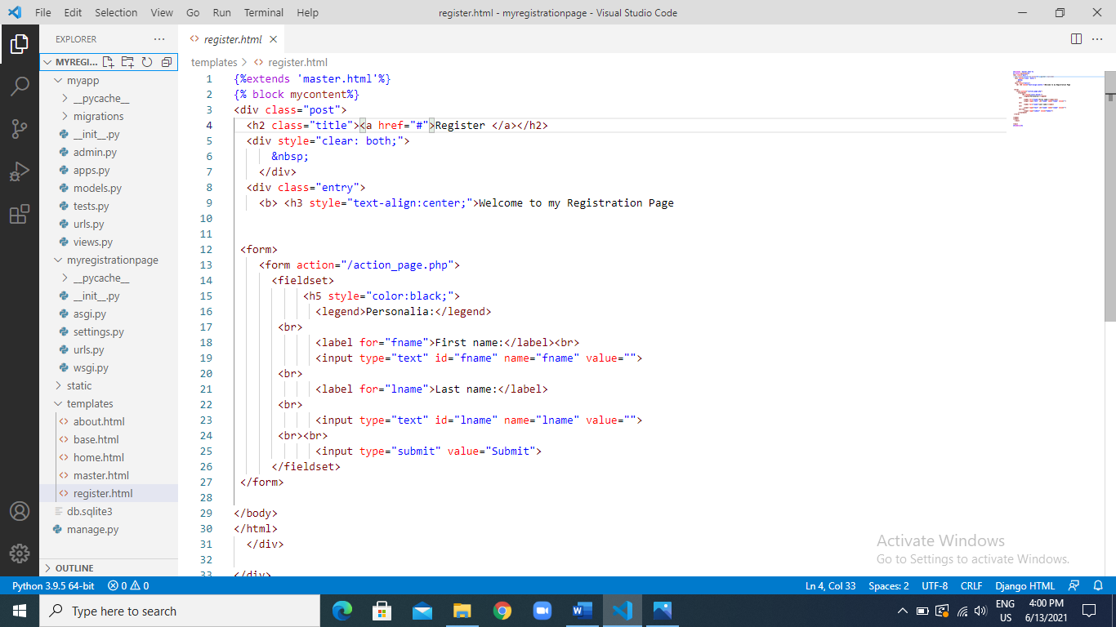

1. VIEW MODULE

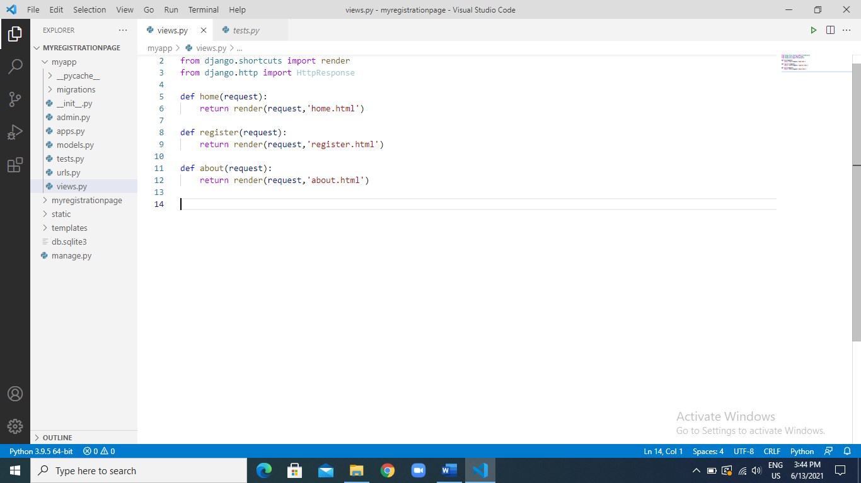

1. MY APP – URLS.PY

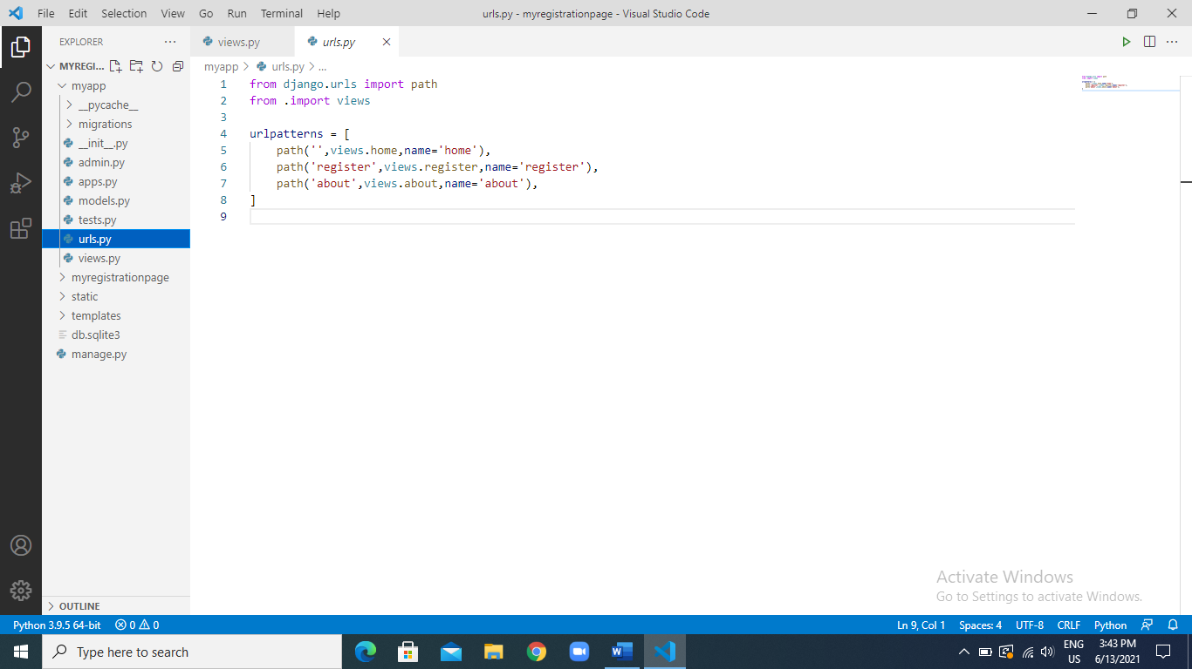

1. ABOUT.HTML

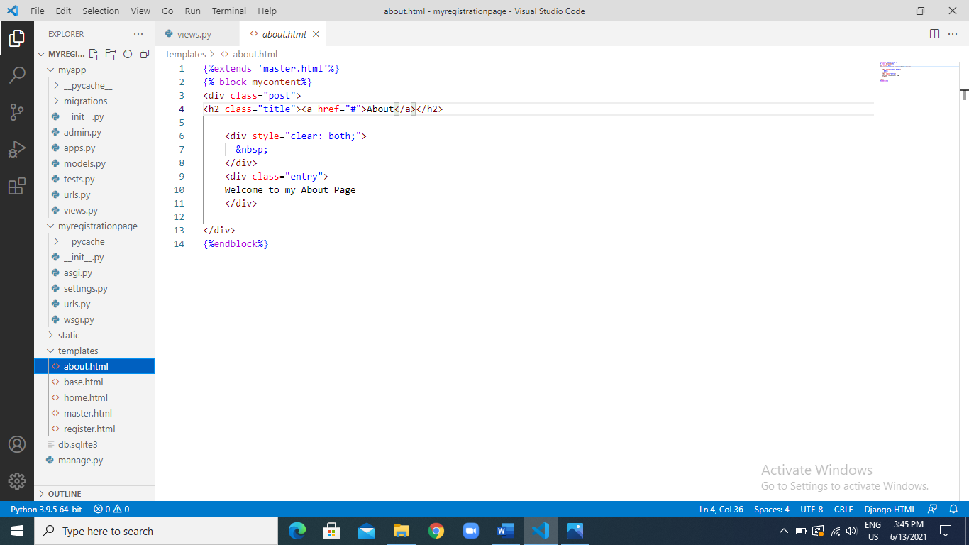

1. BASE.HTML

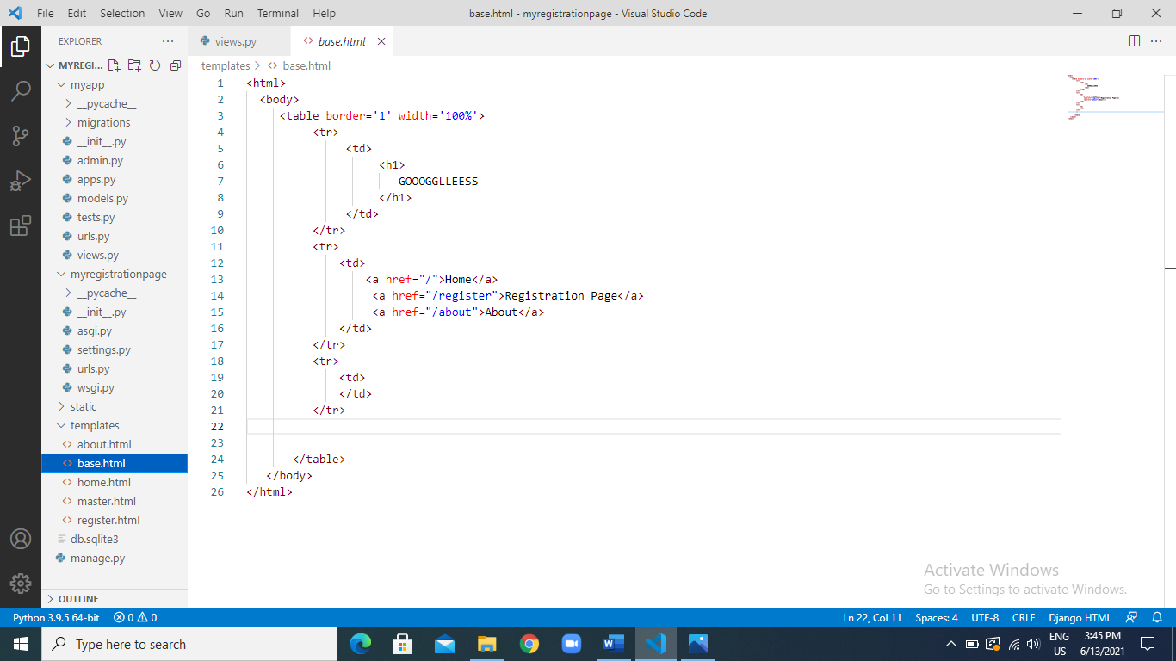

1. HOME.HTML

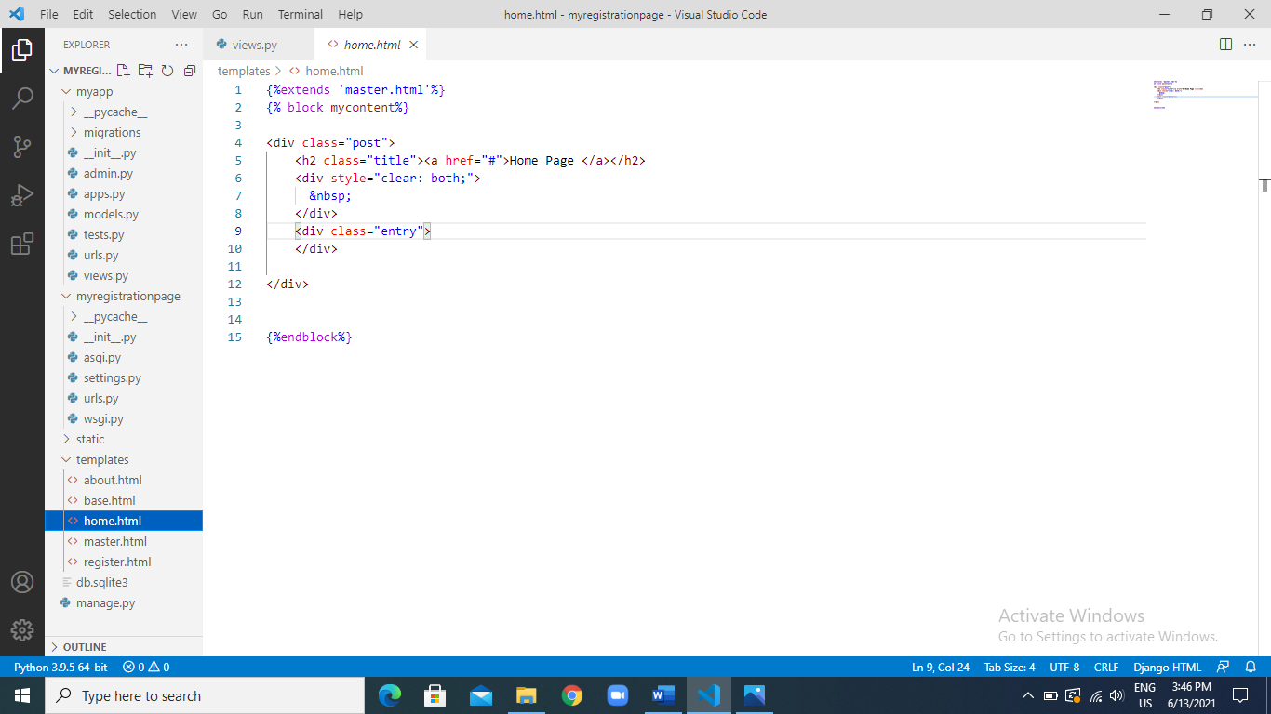

1. MASTER.HTML

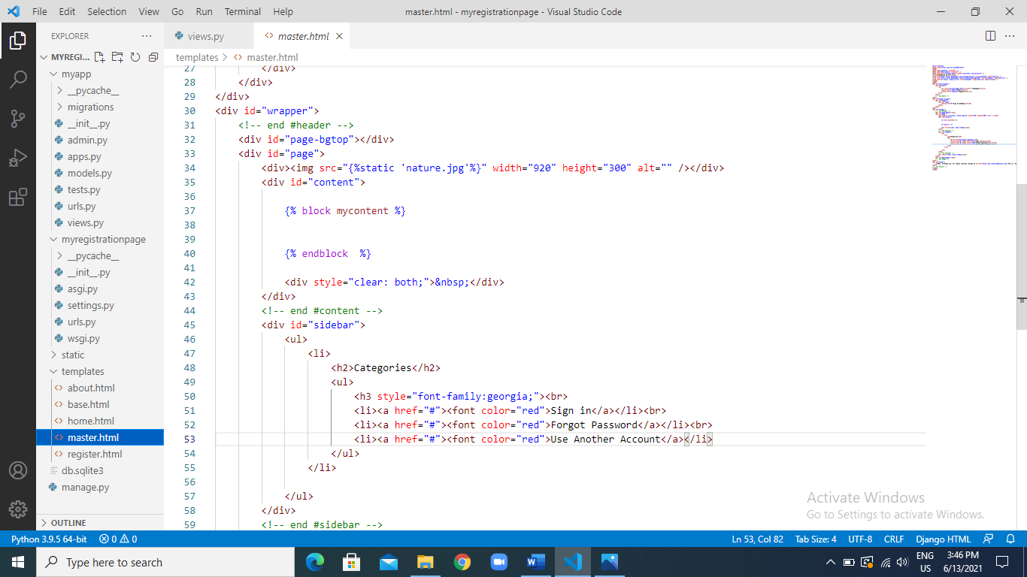

1. REGISTER.HTML

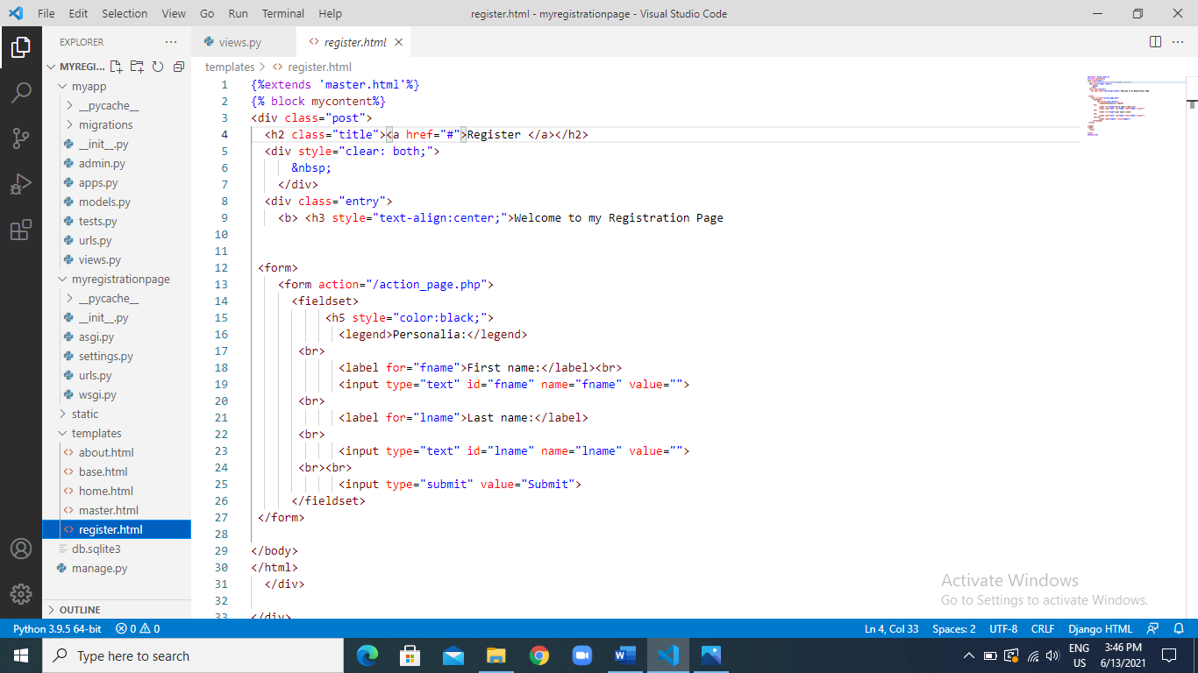

1. THE WEBPAGE

HOME PAGE ::

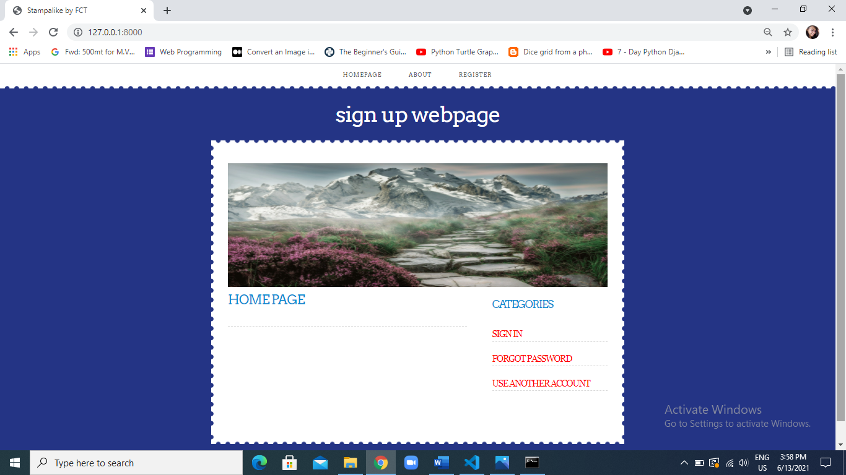

1. ABOUT US PAGE

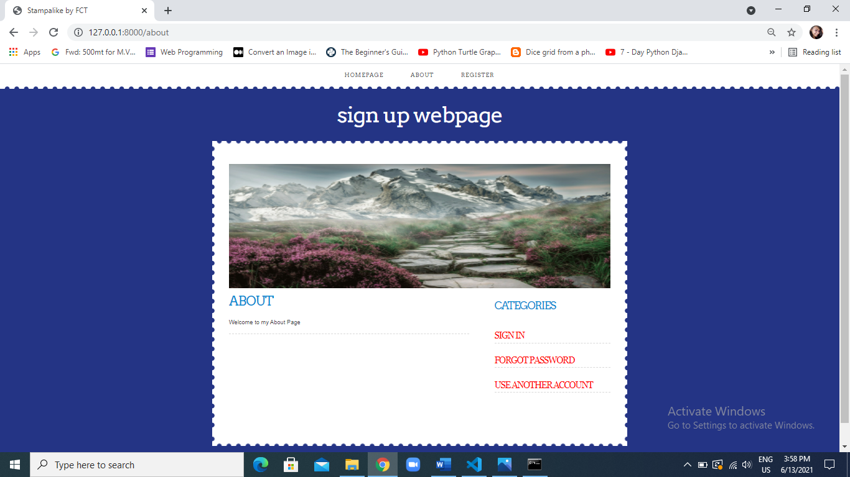

1. REGISTRATION PAGE

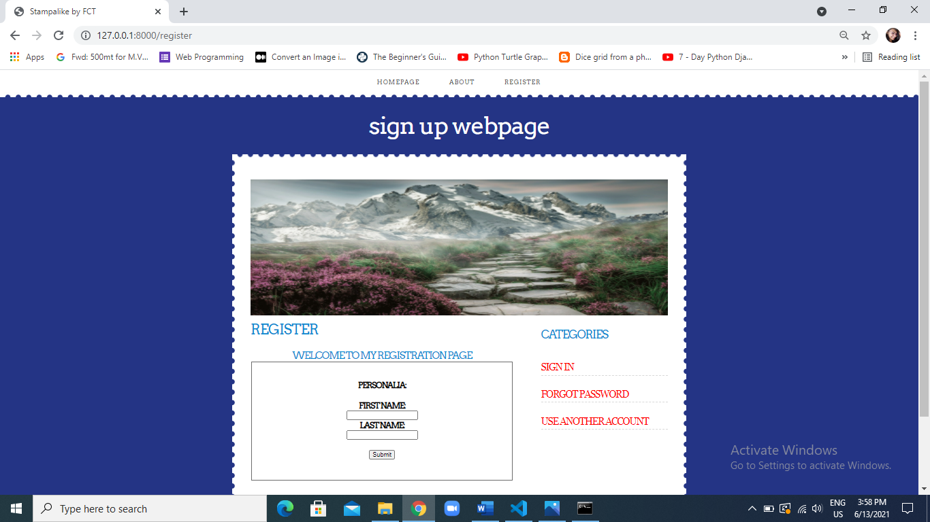

1. REGISTRATION – (2)

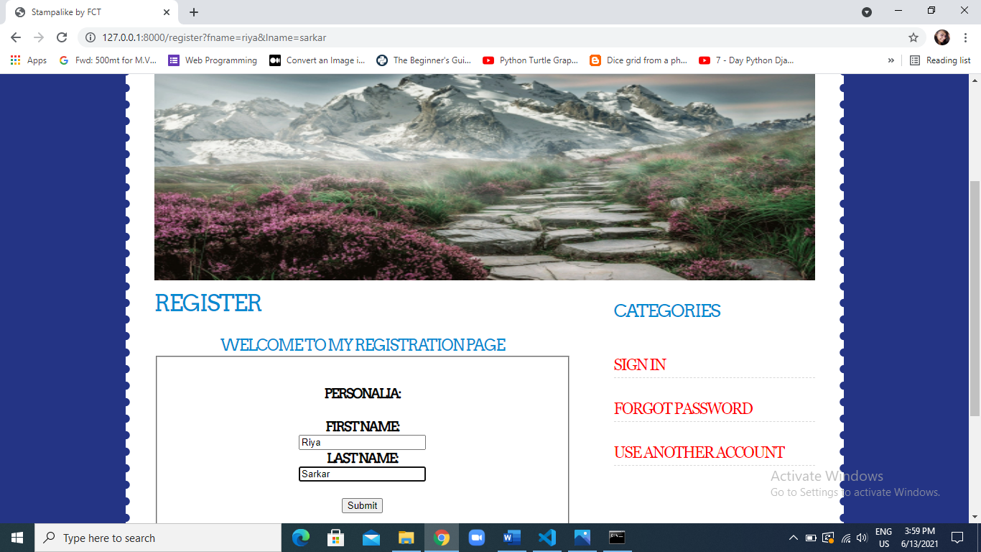

THANK YOU!!!!